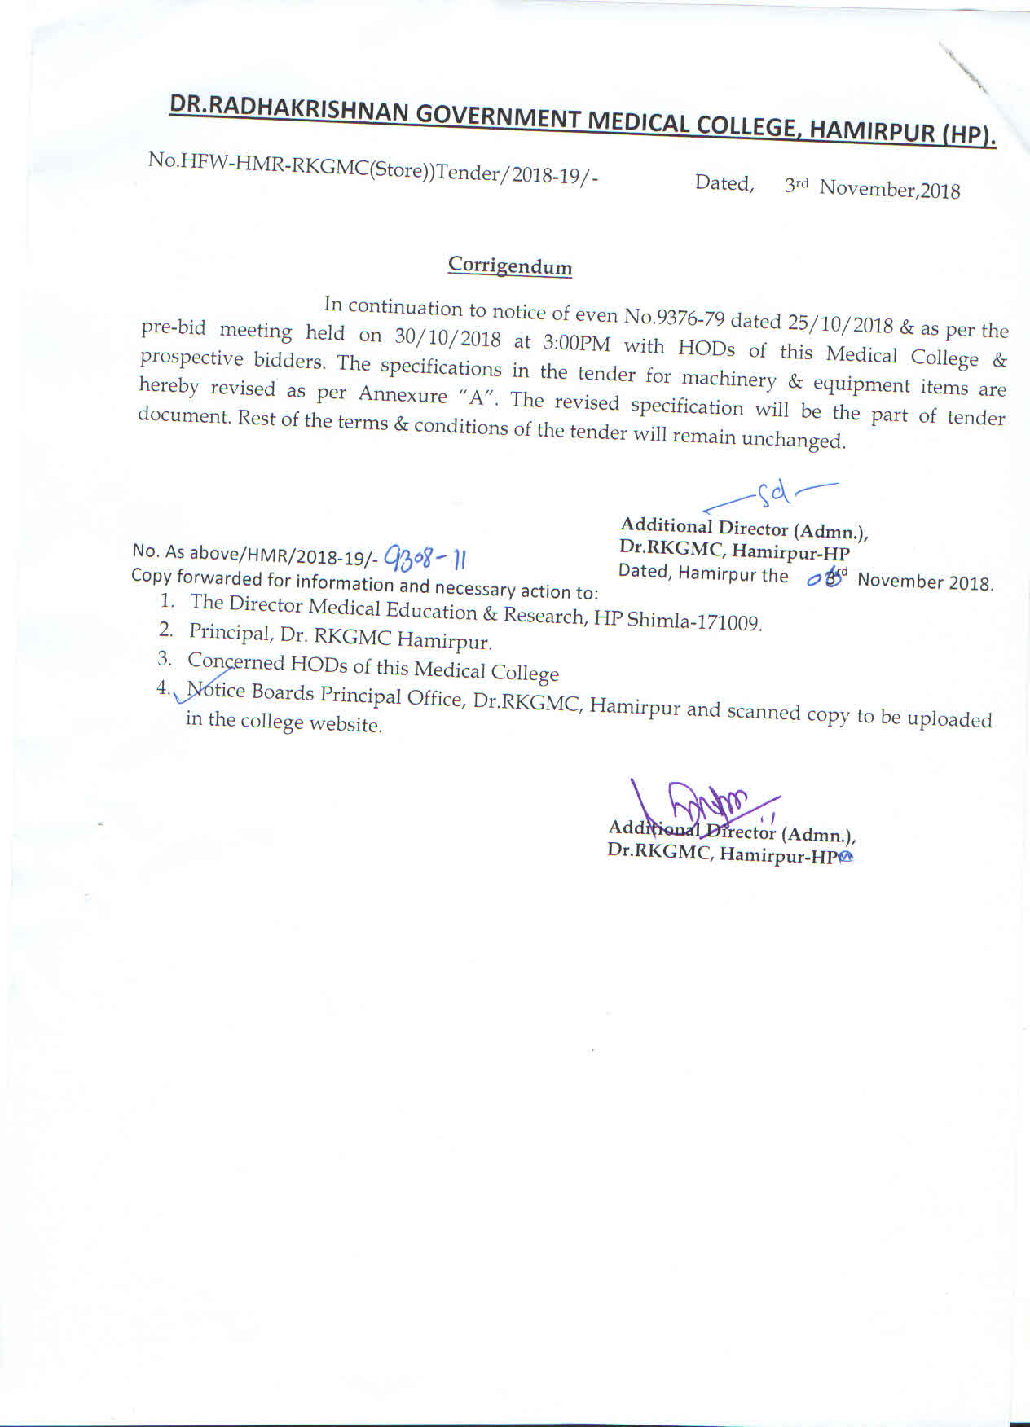
Annexure “A”
Department of Physiology, Dr. RKGMC Hamirpur (HP)
- PHYSIOGRAPH SINGLE CHANNEL
TECHNICAL SPECIFICATION DIGITAL SINGLE PHYSIOGRAPH MACHINE

- Digital Physiograph single channel should have following technical specifications with Single
channel Console with Time & Event Channel and
stimulator for Human & Animal experiments
.
- No. of channels: Single, Display & Size: Coloured TFT: 15.5x9.5 cm, Channel width: 80m,
A/D Conversion: 16-bit A/D, CMRR: >80-85 db
Sensitivity: 50, 100, 200, 500, uv/cm and 1, 2, 5,10,20,50,100 mv/cm
- Sweep Speed: 0.5,.1,.2,.5,1,2,5,10,20,50,100
div/sec., Notch Filter: 50-60 Hz
- Data Sampling Frequency: >256 Hz, Input Impedance: >1 Mega Ohm,
- System should have following features:-
- Standalone unit having coloured TFT Display for displaying online & offline Recording data.
- Systems have six couplers fitted in a Single unit easy to carry & light weight.
- System with Eight Transducers (Force, Pressure, Volume, Respiration, Temperature, Pulse,
Respiration Belt, and Isotonic) -Interface to the
Computer- Through USB.
- System provided with software to review and printing the recorded data from
PC.(optional)
- System should be supplied with Digital Mono Bath with following specification
& features:-
- Leak proof dovetailed joints of transparent perspex.
- Digital Temperature controlled built in LED/LCD temperature display provided in
the main single unit.
- Independent electro valve for chamber filling and emptying controlled by push button.
- Tissue washing achieved without exposing tissue to air.
- Use of safety sensor for both water level and water temperature cut off.
- Should have facility to provides to fill and drain the solution from chamber by push button controlled electro valve without exposing tissue to air.
- Bath size 9”x 7”x7”, Chamber size 10ml.25ml & 50ml. Temp. Range 10-50 ℃ &warming coil Dia 1.5” & Tissue holder with stand.
- Should have following Couplers, Transducers & Accessories:-
- Strain Gage, Isotonic, Pulse Respiration, Temperature, EKG (CLINICAL) with
Electrode, 5 pin Junction box and Jelly, Bio Potential (with Electrodes, 3 pin Junction box, Paste and Electrode for Action Potential).
- Pressure for strain gage Coupler, Volume for strain gage Coupler, Pulse for Pulse Respiration Coupler, Temperature for Temperature Coupler, Muscle Activity/Force for strain gage Coupler, Respiration Belt for Pulse Respiration Coupler, Isotonic Fine Movement for isotonic Coupler .
- Fuses- 5, Ear thing cord- 1, Instruction Manual- 1, Machine cover- 1, Software Back up on C/D- 1 & USB Cable-1. EEG & EMG paste.
- Marriot bottle with stand, tubing and another accessories.

WARRANTY AND CMC : Warranty 2 YEARS AND CMC 5 years.

- PHYSIOGRAPH THREE CHANNEL
TECHNICAL SPECIFICATION DIGITAL SINGLE PHYSIOGRAPH MACHINE

- Digital Physiograph single channel should have following technical specifications with Single
channel Console with Time & Event Channel and
stimulator for Human & Animal experiments
.
- No. of channels: Single, Display & Size: Coloured TFT: 15.5x9.5 cm, Channel width: 80m,
A/D Conversion: 16-bit A/D, CMRR: >80-85 db
Sensitivity: 50, 100, 200, 500, uv/cm and 1, 2, 5,10,20,50,100 mv/cm
- Sweep Speed: 0.5,.1,.2,.5,1,2,5,10,20,50,100
div/sec., Notch Filter: 50-60 Hz
- Data Sampling Frequency: >256 Hz, Input Impedance: >1 Mega Ohm,
- System should have following features:-
- Standalone unit having coloured TFT Display for displaying online & offline Recording data.
- Systems have six couplers fitted in a Single unit easy to carry & light weight.
- System with Eight Transducers (Force, Pressure, Volume, Respiration, Temperature, Pulse,
Respiration Belt, and Isotonic) -Interface to the
Computer- Through USB.
- System provided with software to review and printing the recorded data from
PC.(optional)
- System should be supplied with Digital Mono Bath with following specification
& features:-
- Leak proof dovetailed joints of transparent perspex.
- Digital Temperature controlled built in LED/LCD temperature display provided in
the main single unit.
- Independent electro valve for chamber filling and emptying controlled by push button.
- Tissue washing achieved without exposing tissue to air.
- Use of safety sensor for both water level and water temperature cut off.
- Should have facility to provides to fill and drain the solution from chamber by push button controlled electro valve without exposing tissue to air.
- Bath size 9”x 7”x7”, Chamber size 10ml.25ml & 50ml. Temp. Range 10-50 ℃ &warming coil Dia 1.5” & Tissue holder with stand.
- Should have following Couplers, Transducers & Accessories:-
- Strain Gage, Isotonic, Pulse Respiration, Temperature, EKG (CLINICAL) with
Electrode, 5 pin Junction box and Jelly, Bio Potential (with Electrodes, 3 pin Junction box, Paste and Electrode for Action Potential).
- Pressure for strain gage Coupler, Volume for strain gage Coupler, Pulse for Pulse Respiration Coupler, Temperature for Temperature Coupler, Muscle Activity/Force for strain gage Coupler, Respiration Belt for Pulse Respiration Coupler, Isotonic Fine Movement for isotonic Coupler .
- Fuses- 5, Ear thing cord- 1, Instruction Manual- 1, Machine cover- 1, Software Back up on C/D- 1 & USB Cable-1. EEG & EMG paste.
- Marriot bottle with stand, tubing and another accessories.

WARRANTY AND CMC : Warranty 2 YEARS AND CMC 5 years.

DEPARTMENT OF RADIO-DIAGNOSIS
1. 100 mA Mobile X-Ray Machine
The mobile x-ray equipment would be required to perform x-ray studies in emergency and Trauma Center and at the bedside in wards and ICU. The unit should be compact, lightweight and easily transportable. It should have following specifications:
Generator | A high frequency generator with the following features:  a. Power : 4 KW or more  b. kVp Range: 40-100 KVp or more  c. mAs Range : 250 m As or more  d. m A Range : 10 mA to 100 mA or more  e. Exposure Time : 10 ms to 5 sec.
Digital display | kV and mAs parameters, system ON, System OFF, status and fault message on the kV and mAs are.
X-Ray Tube | Stationary/Rotating anode tube with focal spot 1.8X1.8 mm or less.
Tube Stand | The stand should be fully counterbalanced with rotation in all directions.
Collimator | Collimator rotation should be + 90 to -90 degrees with auto shut off lamp facility.
Cassette storage box | The equipment should have cassette storage box for minimum of 5 cassettes.
Electrical requirement | The unit should be operational on main voltage from single phase 180-240 v AC with automatic main compensation.
Ergonomics | The unit should have small foot print. The height of the column stand should be more than 150 cm for easy transportation in the lift etc. and areas with small height doors. The equipment should be light weight, not more than 160 kg.
Breaking System | The unit should have effective breaking system for parking.
Installations | The bidder should have installed same model successfully in India. The copy of the satisfactory performance certificate of same model to be enclosed along with the bid.
Certification | System shall have valid AERB certificate of the quoted model. The bidder to provide any other certificate required for importing the equipment in case of imported models. Onsite registration and approval of AERB form machine will be the responsibility of the supplier.
Product Data Sheet | All technical specification should be supported with original date sheet highlighting the page number in the compliance sheet. Photocopy/computer print will not be acceptable.
The rates of the equipment should be quoted with 5 years onsite warranty and CMC for 5 years.
Accessories:-
Two sets of CR Cassettes of 14”x17” & 10”x12” size. Compatible with CARESTREAM DIRECT VIEW VITA CR SYSTEM
Lead Alphabets and numbers 3 sets.
BARC Approval light weight lead gowns with lead equivalent of 0.5 mm or better- 2 No.s with hangers
Lead partition for Radiography.

2. Specification for mobile 60 MA high frequency X-ray machine with battery back up
- X-Ray generator:-
- Power: 2.5KW or more
- Maximum KV: 100
- Max mA: 60
- Max range: upto 200 mAS
- Exposure time: 20 msec to 5 sec or less
- X-ray tube: Stationary or Rotating Anode with focus spot less than 0.6 to 2.2mm or better
- Tube Stand: The tube stand should be fully spring/ counter balanced with rotation
- Light beam diaphragm collimator
- Integrated Cassettes box
- AERB approved

Accessories:-
Two sets of CR Cassettes of 14”x17” & 10”x12” size. Compatible with CARESTREAM DIRECT VIEW VITA CR SYSTEM
Lead Alphabets and numbers 3 sets.
BARC Approval light weight lead gowns with lead equivalent of 0.5 mm or better- 2 No.s with hangers
Lead partition for Radiography.

DEPARTMENT OF OPHTHALMOLOGY, DR.RKGMC & H, HAMIRPUR (HP).
SPECIFICATION OF ADVANCED PHACO EMULSIFICATION MACHINE
- Fully Programmable Multiprocessor Control System
- Flat screen, Coloured display with touch screen or button mode.
- Should have the ability to control via footswitch and front panel.
- Should have programmable footswitch.
- Should have the ability to drive high performance four to six crystal hand piece; Ultrasound Frequency 25-43 kHz, piezoelectric effect, slim, lightweight and autoclavable.
- Should be equipped with option of 2.2 mm, 2.8 mm size of phaco tip.
- The ultrasound & hand piece should be compatible with tips.
- Should have facility of ultrasound power control in various sub modes like continuous, pulsed & burst.
- Should have advanced fluids technology- Venturi/Peristaltic/Dual with the facility to use vaccum level upto 600 mmHg or better and aspiration flow rate upto 50 cc/min or better to provide excellent chamber stability.
- Should have Voice/Audio confirmation during mode changes.
- Should have ability to drive electric/pneumatic cutter for anterior vitrectomy.
- Should have automated IV pole controlled by foot pedal & front panel.
- Should have wireless remote control.
- Should have bipolar coagulation capability panel or linear power control by foot pedal.
Accessories Required
- Phaco Hand Pieces-2
- Phaco tip 2.8mm-3
- Phaco Tip 2.2mm-1
- Phaco Sleeve 2.8mm-10
- Phaco Sleeve 2.2mm-5
- Phaco Cassettes/tubing sets- 05 (if Disposable tubing then required quantity is 5000
- I/A Handpiece-2 (Bimanual-1, Coaxial 1)
- Vitrectomy Cutter-5
- Hand piece test chamber.
- Diathermy-1
- Sterilization Container-2
- Wireless Remote-1
- Wrench-1
Certification, Warranty & CMC
- Should have safety certificate from a competent authority CE/FDA(US)/STQC S certificate or valid detailed electrical and functional safety test report from ERTI. Copy of the certificate / test report should be produced along with the technical bid.
- Onsite Warranty – 5 years.
- CMC – 5 years after onsite warranty.

DEPARTMENT OF ANESTHESIA, DR.RKGMC, HAMIRPUR
- ANESTHESIA WORKSTATION SPECIFICATION
- The unit should be a cost effective, flexible anesthesia workstation for performing and monitoring inhalation anesthesia, suitable for Adult as well as Child upto neonatal age.
- It should be capable of providing low-flow technique to minimize gas and anesthetic agent consumption for economic day-to-day operation. It should give and agent consumption data.
- The Anesthesia Workstation should have in-built Ventilator with Coloured touch screen 10-15 inch TFT display, integrated CO2 absorber, in-built & integrated anesthesia Gas Monitoring Facility, vaporizers and 15” Multi parameter monitor. All these components should be the same manufacturer or brand with their label on each component.
- The unit should be able to connect to Central pipeline & there should be provision of one PIN Index Yoke to connect to One Emergency Gas Cylinder of O2 & N2O each. Pipeline inlet for Oxygen, Air, Nitrous Oxide.
- The unit should have Powder Coated Steel Trolley with 4 Wheels & 3 Drawers & the front wheels should have locking device. The unit should have Rail on one side to mount other equipment’s.
- Gas delivery system with digital virtual display of the flowmeters for O2, N2O and Air. Total flowmeter tube for total FG.
- Hypoxic guard to provide a nominal minimum 25% concentration of oxygen in O2/N2O mixture. It should have proven hypoxia guard design using the Pin-valve Mechanism or equivalent mechanism.
- The machine to have Auxiliary Oxygen Flowmeter.
- Clock and timer- Tourniquets, certain drug delivery, cross clamping of vessels-many operating room events need timing, to offer a handy clock and timer, right on the screen
- Oxygen Flush : Range 25 to 75 L/min.
- It should be equipped with self-test routines and automatic calibration of all sensors. The machine checks out should calibrate all the sensors, calculate the leak and compliance. Preferable to do even the vaporizer leaks test in the machine check out is needed.
- The unit should have Common Gas Outlet for using open circuit & the unit should have easy change over from open circuit to closed circuit or vice-versa.
- International Standards:- The unit should comply with international Standards Y should have CE Marking , AAMI ES60601-1, CSA C22.2 #601.1, EN/IEC 60601-1, ISO 80601-2-13 Quality Systems-Medical Devices. Fillers for Isoflurance & Sevoflurance

- BREATHING SYSTEM (CLOSE CIRCUIT SYSTEM)
- It should be integrated to the CO2 absorber of minimum 1.0 Kg & CO2 absorber should be Single/ Double chamber design having easy removal & re-fitting during the operation. Battery Backup upto 1 hr.
- it should have the fully autoclavable at 134 deg C. It should have Pressure Graduated Metallic APL Valve, and Inspiratory Valve, Expiratory Valve and Bag to Vent switch to easily move from ventilator to manual bag ventilation.
- The machine should have patient airway pressure monitoring giving the Pmax, Pmean, and Peep values.
- Machine shall provide circle mode breathing circuit, Reusable closed ckt for adult and neonate

- Vaporizers
it should have provision to connect Two Selectatec mount vaporizers & the unit should be provided with two vaporizers equivalent to TEC-7 type, One of Isoflurance& Sevoflurance form the same manufacturer.
- Integrated Anesthesia Ventilator: in built Anesthesia Ventilator:
- It should have integrated Microprocessor Controlled & Pneumatically Driven Ventilator with bellows and the same bellows should be useful for Pediatric & Adult Application, thus avoiding change of bellows.
- The unit should have fresh Gas De-coupling or Continual fresh gas flow with fresh gas flow compensation during mechanical ventilation.
- Modes of Ventilation: VCV, PCV, SIMV+PS, PSV
- Cardiac Bypass Mode during cardiac bypass procedure to stop the system from alarming, and turns off automatically, when the ventilator is turned back on. Complete Patient spirometry with all the 3 loops and save loop feature should be available.
- Tidal Volume: Tidal volume delivery 20ml to 1500ml in Volume Controlled modes.
- Rate : 4 to 60bpm.
- Peep: Off, 0 to 20cmH2O.
- Settable I:E ratios, Pause, Trigger (0.2-10 L/min), Insp Pressure from 5 upto 60CMC H2O.
- Ventilator shall be capable of 120+ L/min peak flow.
- Compliance Measurement and Trending (Preferable): Measures and display the patient’s compliance to offer a view of the patient’s lung condition.
- It should have a high contrast color 10-15” inch TFT Display.
- Gas Monitoring: - The In-built Anesthesia Gas Monitoring Facility should base on side-stream technology; using infra-Red Photometry Principal & also it offer Automatic Anesthetic Agent Identification. (AGM Module should be swappable to plug in either Anesthesia machine of Patient Monitor.
- Cardiac Output (optional)
Specifications:-
CO2 Et. & In: Display : 0-10%, 0-76 mmHg
Accuracy: +/-0.5 vol% or +/-12% rel.
Reaction time: <500 ms 150ml/min
N2O In & Et.: Display : 0-100
Accuracy: +/-2 Vol% Or +8% rel
Reaction time: <500ms 150ml/min
O2 (paramagnetic) In & Et.: Display: 0-100%
Reaction time: <500 ms 150ml/min
Anesthetic agent:
Halothane, Isoflurance : Display : 0-8.5 Vil%
Enflurane, Sevflurane : Display: 0-10 Vol%
Desflurane : Display: 0-22%
Accuracy : 0-1.15% or +15% rel.
MAC:- it should have display of MAC (minimum Alveolar Concentration).
- Alarms:- it should have clear alarms and user information as text messages. It is essential that unit should prompt user for corrective action rather than giving only alarm with no diagnostic message.

- SPECIFICATIONS FOR MULTI PARAMETER PATIENT MONITOR:
- Parameters:- Should be capable of Monitoring Heart rate,SPO2, NIBP,ECG,2x Temp, RR and 2xIBP (Upgradable to 4).
- Display:- Should have a Display of Minimum 15 inch Medical Grade high Resolution Active matrix TFT LCD with Touch screen on primary display.
- Should operate through Rotary knop & Membrane keyboard.
- Fields:- Should have 8 waveform fields.
- ECG:- Should have provisions to connect 3 or 5 Lead ECG cables & Should be able to perform Multi-lead (upto 4) arrhythmia analysis at the bedside.
- NIBP:- Should have NIBP measurement by Osillometric method with double lumen tubing. Should have Manual/ Automatic modes of measurement. Should have a measurement range of 20 to 250 mm Hg.
- Invasive BP:- Should have 2 channel Invasive Blood pressure (IBP) measurement. – Should have waveform IBP 1 and IBP 2.
- Temperature:- Should have provision for two temperatures with display of T1 and T2.
- Respiration:- Should have Respiration by Impedance method.
- SPO2:- It must use Low perfusion technology to measure oxygen saturation for accuracy during motion artifacts, low perfusion states like shock, bradycardia and hypothermia. Should have SPO2 measurement with plethysmograph, and SPO2 values with range 50% to 100%.
- Alarm facility: Should have Alarm facility for HR limits, Arrhythmia, ST Segment Limit, and all other parameter limits.
- Graphs & Trends: Should have 96hr Graphical and Tabular Trend for NIBP, HR, SPO2, RR, IBP, IPB2, T1,T2, AWRR, ST, Segment.
- Facility to store snapshots during critical events for waveform review at a later stage.
- Audio visual and graded alarming system.
- Dedicated software and parameters to monitor physiological parameters of patient’s in OR
F . System Configuration Accessories, Spares and consumables:-
Should be supplied with the following Standard Accessories
- 3 Lead ECG cable- 2 Nos. 5 Lead ECG cable – 2 Nos.
- SPO2 finger probe for Adult and Pediatric application- 1 each.
- NIBP cuff for Adult and Pediatric application.
- 2 IBP Transducers with cable.
- 2 Temperature Probes.
- Disposable Adult & Pediatric circuits 50 each.
- HME filters- 50.
- AGM Module.
- Air, O2 & N2O Hoses.
- Adult Ckt Resuable.
- Pead Ckt Resuable.
- Bag of different sizes.

Environmental Factors:-
- The unit shall be capable of operating continuously in ambient temperature of 10-40 deg C and relative humidity of 15-90%.
- The shall be cables of being stored continuously in ambient temperature of 0-50 deg C and relative humidity of 15-90%.
- Shall meet IEC-60601-1-2: 2001(or Equivalent BIS) General Requirements of Safety for Electromagnetic Compatibility or should comply with 89/366/EEC; EMC directive.
Power Supply
- Power input to be 220-240V AC, 50Hz fitted with Indian plug.
- Voltage corrector/stabilizer of appropriate ratings meeting ISI Specifications. (Input 160-260 V and output 220-240 V and 50 Hz).
- Should provide suitable isolation Transformer with true online UPS with maintenance free batteries for minimum one hour back up should be supplied with the system.
Standard, Safety & Training:-
- Should be European CE & US FDA approval product.
- Shall meet the safety requirements as per IEC 60601.
- Particular requirement for the safety of electrocardiographic monitoring equipments.
- Manufacturer/ Supplier should have ISO certification for quality standards.
- Should have local service facility. The service provider should have the necessary equipments recommended by the manufacturer to carry out preventive maintenance test as per guidelines provided in the service/maintenance manual.
- Back to back warranty to be taken by the supplier from the principal to supply spares for a minimum period of 10 years.
- Comprehensive onsite warranty for 5 years and provision of CMC for next 5 years.
Documentation:-
- Log Book with instruction for daily,weekly, monthly and quarterly maintenance checklist.
- The job description of the hospital technician and comply service engineer should be clearly spelt out.
- Complete workstation should be of same company, otherwise will be rejected.

